P Online Python CompilernterF X G N=8 def print_solution(board): X + X

C ;; programiz.com/python-programming/online-compiler/

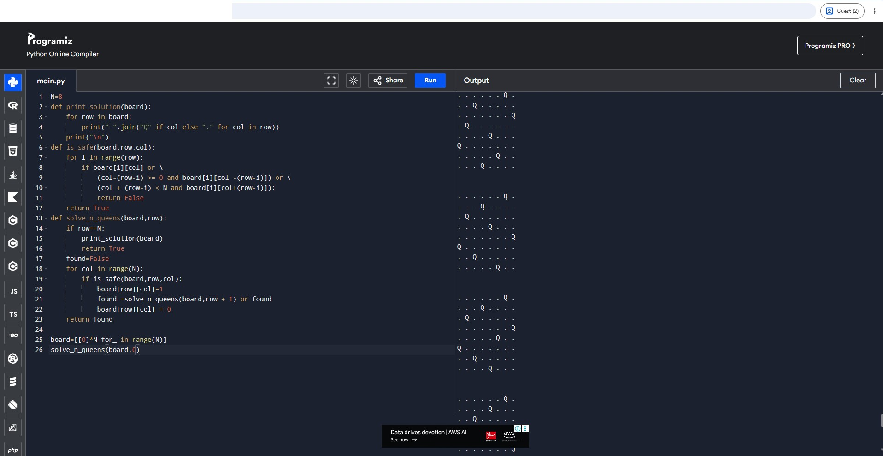30"C ■■ ft ,,,.,. • • I':' ""] '
!-
>:
- Mo>tlycloudy ■■ 111101
- ..E.l ed 'iJ.) • ,

09 21
ENG
"' <J IN C:.? c:J>)) 22-07-2026

